Rikki-Tikki-Tavi by Rudyard Kipling

Teacher Guide by Becky Harvey

Find this Common Core aligned Teacher Guide and more like it in our Middle School ELA Category!

Student Activities for Rikki-Tikki-Tavi Include:
- Plot Diagram | "Rikki-Tikki-Tavi" Summary
- Cause and Effect
- Character Map for "Rikki-Tikki-Tavi"
- Personification in "Rikki-Tikki-Tavi"
- Making Predictions in "Rikki-Tikki-Tavi"
"Rikki-Tikki-Tavi" by Rudyard Kipling is the story of a brave young mongoose who keeps a human family and a number of animal friends safe from the vicious, murderous cobras who slither through the garden.
By the end of this lesson your students will create amazing storyboards like the ones below!
(Learn More about our Educational Version)

Rikki-Tikki Tavi Plot Diagram

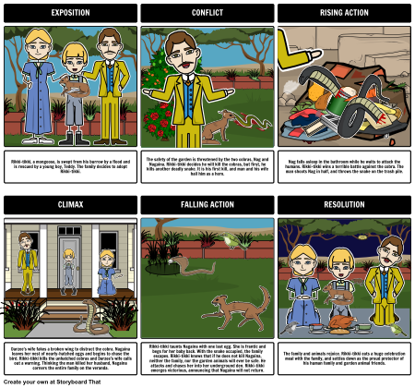
Rikki-Tikki-Tavi - Cause and Effect

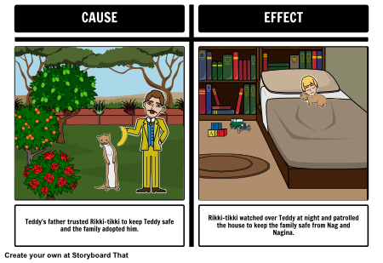

Rikki-Tikki-Tavi Character Map
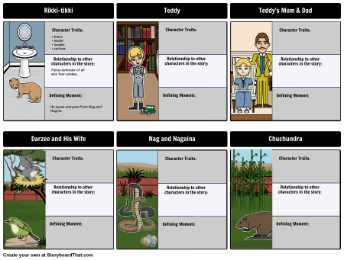

Rikki-Tikki-Tavi - Predictions
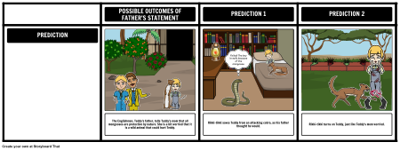

Rikki-Tikki-Tavi Personification
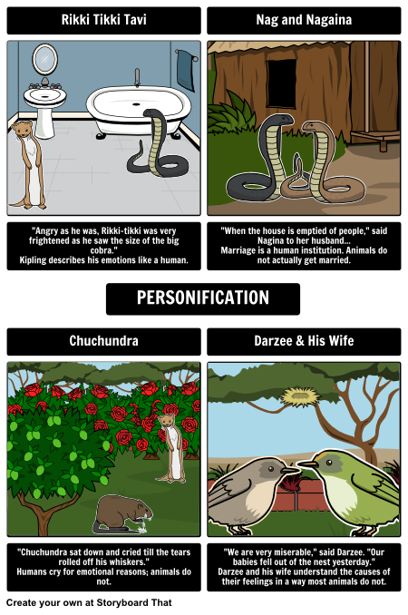

A Quick Synopsis of "Rikki-Tikki-Tavi" (Contains Plot Spoilers)
In the Segowlee cantonment, the British living quarters in India during World War I, Rikki-tikki, a mongoose, is swept from his burrow by a flood. Rescued by Teddy, the young son of a British family, Rikki-tikki is nursed back to health and adopted by the family. At first, Teddy’s mother worries that Rikki-tikki might be too wild and would be dangerous to have around Teddy. Teddy’s father reassures her that mongooses are not only safe to have in a house, but excellent protectors against deadly snakes.
Rikki-tikki makes friends with some of the animals in the garden. There are two cobras, Nag and Nagaina, who terrorize the birds and other animals. Darzee, a bird who lives in the garden, and his wife have lost one of their fledglings to the snakes. Darzee begs Rikki-tikki to keep them and their children safe. Rikki-tikki decides he will kill the cobras, but first, he kills another deadly snake. It is his first kill, and his family are impressed. He is hailed a hero. This only makes Rikki-tikki want to kill Nag and Nagaina more. He feels responsible for the safety of the family and the garden animals.
One night, Nag and Nagaina plot to kill the human family. Nag falls asleep in the bathroom while he waits for the man to come in for his morning bath. Rikki-tikki watches and waits for the right moment, then attacks. The mongoose wins a terrible battle against the cobra. Teddy's father shoots Nag in two, only after Rikki-tikki has killed him, and throws the snake on the trash pile.
Rikki-tikki and Darzee’s wife make a plan to get Nagaina away from her eggs. Darzee’s wife fakes a broken wing, making a racket to distract the cobra. Nagaina leaves her nest of nearly-hatched eggs and begins to chase the bird. Rikki-tikki kills the unhatched cobras and Darzee's wife calls out a warning to him. Thinking the man killed her husband, Nagaina has cornered the entire family on the veranda.
Rikki-tikki brings one last unhatched egg and taunts Nagaina. She is frantic and begs for her baby back. With the snake occupied, the family escapes. Rikki-tikki knows that if he does not kill Nagaina, neither the family, nor the garden animals will ever be safe. He attacks and chases her into her underground den. Darzee sings a sad song, saying that Rikki-tikki must be dead, for nothing can beat a cobra in its own den. Rikki-tikki, however, emerges victorious, announcing that Nagaina will not return.
The family and animals rejoice. Rikki-tikki eats a huge celebration meal with the family, and settles down as the proud protector of his human family and garden-animal friends.

Essential Questions for "Rikki-Tikki-Tavi"
- How does our "nature" define us?
- Is trust earned or given?
- How is trust lost?

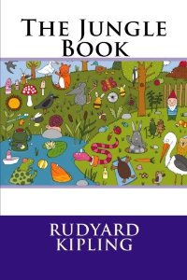
Buy The Jungle Book by Rudyard Kipling on Amazon

Rikki-Tikki-Tavi Lesson Plans, Student Activities and Graphic Organizers

Plot Diagram | "Rikki-Tikki-Tavi" Summary

Lesson Plan Reference
Print Activity
Grade Level: 6-8
Difficulty Level: 2 (Reinforcing / Developing)
Type of Assignment: Individual or Partner
Type of Activity: Plot Diagrams and Narrative Arcs
Common Core Standards:
- [ELA-Literacy/RL/8/2] Determine a theme or central idea of a text and analyze its development over the course of the text, including its relationship to the characters, setting, and plot; provide an objective summary of the text
- [ELA-Literacy/RL/8/5] Compare and contrast the structure of two or more texts and analyze how the differing structure of each text contributes to its meaning and style
- [ELA-Literacy/RL/8/10] By the end of the year, read and comprehend literature, including stories, dramas, and poems, at the high end of grades 6–8 text complexity band independently and proficiently
A common use for Storyboard That is to help students create a plot diagram of the events from a story. Not only is this a great way to teach the parts of the plot, but it reinforces major events and help students develop greater understanding of literary structures.
Students can create a storyboard capturing the narrative arc in a work with a six-cell storyboard containing the major parts of the plot diagram. For each cell, have students create a scene that follows the short story in sequence using: Exposition, Conflict, Rising Action, Climax, Falling Action, and Resolution.

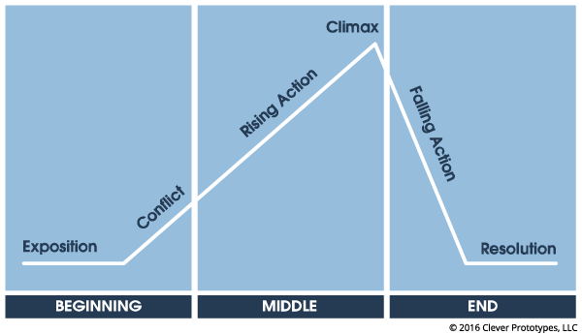
( Read Lesson Plan • Buy Poster • Buy PDF )

Example "Rikki-Tikki-Tavi" Plot Diagram

Exposition
Rikki-tikki, a mongoose, is swept from his burrow by a flood and is rescued by Teddy. Teddy’s father, the Englishman, says mongooses are not only safe to have in a house, but excellent protectors against the deadly snakes in the area. The family adopts Rikki-tikki.

Conflict
There are two deadly cobras, Nag and Nagaina, who threaten the safety of the garden. Rikki-tikki decides he will kill the cobras, but first, he kills another deadly snake. It is his first kill, and the Englishman and his wife are impressed. He is hailed a hero. This only makes Rikki-tikki want to kill Nag and Nagaina more. He feels responsible for the safety of the family and the garden animals.

Rising Action
Nag decides to sneak into the house to kill the humans. He falls asleep in the bathroom while he waits for the humans to wake up. Rikki-tikki realizes he is there and attacks. The mongoose wins a terrible battle against the cobra. In the morning, the Englishman again hails Rikki-tikki a hero, chops Nag in half, and throws the snake on the trash pile.

Climax
Nagaina, thinking the man killed her husband, tries to kill the human family. Darzee’s wife fakes a broken wing, making a racket to distract Nagaina, who has cornered the entire family on the porch. Nagaina, unable to resist an easy kill, begins to chase the bird. With the snake occupied, the family escapes, and Rikki-tikki kills the unhatched cobras. He smashes all but one of the eggs, but realizes that Nagaina is preparing to bite Teddy.

Falling Action
Rikki-tikki brings the last egg and taunting Nagaina. She begs for her baby back. Rikki-tikki knows that if he does not kill Nagaina, neither the family, nor the garden animals will ever be safe. He attacks and chases her into her underground den. Darzee sings a sad song, for nothing can beat a cobra in its own den. But Rikki-tikki emerges victorious, announcing that he has killed Nagaina.

Resolution
The family and animals rejoice. Rikki-tikki eats a huge celebration meal with the family, and settles down as the proud protector of his human family and garden-animal friends.

Rikki-Tikki Tavi Plot Diagram
Create your own at Storyboard That EXPOSITION CONFLICT RISING ACTION CLIMAX FALLING ACTION RESOLUTION Rikki-tikki, a mongoose, is swept from his burrow by a flood and is rescued by a young boy, Teddy. The family decides to adopt Rikki-tikki. The safety of the garden is threatened by the two cobras, Nag and Nagaina. Rikki-tikki decides he will kill the cobras, but first, he kills another deadly snake. It is his first kill, and man and his wife hail him as a hero. Nag falls asleep in the bathroom while he waits to attack the humans. Rikki-tikki wins a terrible battle against the cobra. The man shoots Nag in half, and throws the snake on the trash pile. Darzee’s wife fakes a broken wing to distract the cobra. Nagaina leaves her nest of nearly-hatched eggs and begins to chase the bird. Rikki-tikki kills the unhatched cobras and Darzee's wife calls out a warning. Thinking the man killed her husband, Nagaina corners the entire family on the veranda. Rikki-tikki taunts Nagaina with one last egg. She is frantic and begs for her baby back. With the snake occupied, the family escapes. Rikki-tikki knows that if he does not kill Nagaina, neither the family, nor the garden animals will ever be safe. He attacks and chases her into her underground den. Rikki-tikki emerges victorious, announcing that Nagaina will not return. The family and animals rejoice. Rikki-tikki eats a huge celebration meal with the family, and settles down as the proud protector of his human family and garden animal friends.

Example
View Details Create a Copy Slide Show

Cause and Effect

Lesson Plan Reference
Print Activity
Grade Level: 6-8
Difficulty Level: 2 (Reinforcing / Developing)
Type of Assignment: Individual, Partner, or Group
Type of Activity: Teaching Cause and Effect within Plot
Common Core Standards:
- [ELA-Literacy/RL/7/3] Analyze how particular elements of a story or drama interact (e.g., how setting shapes the characters or plot)
When students read a short story like "Rikki-Tikki-Tavi", they should look for why things happen; this is the core of cause and effect. Have students choose two scenes from the story, to illustrate and describe why one thing caused another to happen. For example, Teddy’s mother and father treat Rikki-tikki like a family member, and so Rikki-tikki becomes very protective of the family.

What would be different if a character had chosen to do something differently?
Rikki-Tikki-Tavi - Cause and Effect
Create your own at Storyboard That Teddy's father trusted Rikki-tikki to keep Teddy safe and the family adopted him. Rikki-tikki watched over Teddy at night and patrolled the house to keep the family safe from Nag and Nagina. CAUSE EFFECT

Example
View Details Create a Copy Slide Show

Character Map for "Rikki-Tikki-Tavi"

Lesson Plan Reference
Print Activity
Grade Level: 6-8
Difficulty Level: 3 (Developing to Mastery)
Type of Assignment: Individual, Partner, or Group
Type of Activity: Character Map
Common Core Standards:
- [ELA-Literacy/RL/6/3] Describe how a particular story’s or drama’s plot unfolds in a series of episodes as well as how the characters respond or change as the plot moves toward a resolution
- [ELA-Literacy/RL/8/1] Cite the textual evidence that most strongly supports an analysis of what the text says explicitly as well as inferences drawn from the text
In this activity, students create an outline for the characters in the story, paying close attention to the physical characteristics and the character traits of both major and minor characters. Students can also provide detailed information regarding the character’s actions, how they influence other characters, and how the main character changed over time.
Characters included in this characters map are:
- Rikki-tikki
- Teddy
- Teddy’s Mom and Dad
- Darzee and his wife
- Nag and Nagina
- Chuchundra
Rikki-Tikki-Tavi Character Map
Create your own at StoryboardThat.com Rikki-tikki Teddy Teddy's Mom & Dad Darzee and His Wife Nag and Nagaina Chuchundra Character Traits: Relationship to other characters in the story: Defining Moment: • brave • leader • lovable • curious Fierce defender of all who fear snakes. Character Traits: Relationship to other characters in the story: Defining Moment: Character Traits: Relationship to other characters in the story: Defining Moment: Character Traits: Relationship to other characters in the story: Defining Moment: Character Traits: Relationship to other characters in the story: Defining Moment: Character Traits: Relationship to other characters in the story: Defining Moment: He saves everyone from Nag and Nagina.
Example
View Details Create a Copy Slide Show

Personification in "Rikki-Tikki-Tavi"

Lesson Plan Reference
Print Activity
Grade Level: 6-8
Difficulty Level: 1 (Introducing / Reinforcing)
Type of Assignment: Individual, Partner, or Group
The personification is the attribution of a personal nature or human characteristics to something nonhuman, or the representation of an abstract quality in human form. In this short story by Rudyard Kipling, "Rikki-Tikki-Tavi", the animal characters all have actions and emotions that can be considered human-like.
Each of the animal characters in the book speaks and feels, in one manner or another, like a human. All of the animals interact with one another, share information, and make plans. Have students find an example of this for different characters by making a spider map or Frayer Model. Students should use a quote from the story and explain it to prove that the author has personified the animal in some way.

Personification Examples
CHARACTER | QUOTE | EXPLANATION
Rikki Tikki Tavi | "Angry as he was, Rikki-tikki was very frightened as he saw the size of the big cobra." | Kipling describes his emotions like a human.
Chuchundra | "Chuchundra sat down and cried till the tears rolled off his whiskers." | Humans cry for emotional reasons; animals do not.
Nag and Nagaina | "When the house is emptied of people," said Nagina to her husband... | Marriage is a human institution. Animals do not actually get married.
Darzee & His Wife | "We are very miserable," said Darzee. "Our babies fell out of the nest yesterday." | Darzee and his wife understand the causes of their feelings in a way most animals do not.

Rikki-Tikki-Tavi Personification
Create your own at Storyboard That Rikki Tikki Tavi Nag and Nagaina Chuchundra Darzee & His Wife "Angry as he was, Rikki-tikki was very frightened as he saw the size of the big cobra." Kipling describes his emotions like a human. "When the house is emptied of people," said Nagina to her husband... Marriage is a human institution. Animals do not actually get married. "Chuchundra sat down and cried till the tears rolled off his whiskers." Humans cry for emotional reasons; animals do not. "We are very miserable," said Darzee. "Our babies fell out of the nest yesterday." Darzee and his wife understand the causes of their feelings in a way most animals do not. PERSONIFICATION
Example
View Details Create a Copy Slide Show
Making Predictions in "Rikki-Tikki-Tavi"

Lesson Plan Reference
Print Activity
Grade Level: 6-8
Difficulty Level: 2 (Reinforcing / Developing)
Type of Assignment: Individual, Partner, or Group
Common Core Standards:
- [ELA-Literacy/RL/7/1] Cite several pieces of textual evidence to support analysis of what the text says explicitly as well as inferences drawn from the text
During this short story, students are going to make many predictions, as to what they think is going to happen next. Illustrating these predictions is a great idea for a storyboard. Plan on specific stopping points while reading, and have your students predict what will happen. They will illustrate their prediction in a storyboard cell and use evidence from the text, or prior knowledge, to back up their prediction.
The main focus for this example storyboard is what might happen if the family befriends the mongoose, Rikki-tikki. As the father points out, the animal is wild. He could be tame, or he could be wild and dangerous. Once the family feeds Rikki-tikki and nurse him back to health, then Rikki-tikki could possibly do one of two things: he could protect the family from deadly snakes, or he could attack Teddy.
Rikki-Tikki-Tavi - Predictions
Create your own at Storyboard That The Englishman, Teddy's father, tells Teddy's mom that all mongooses are protective by nature. She is a bit worried that it is a wild animal that could hurt Teddy. Rikki-tikki saves Teddy from an attacking cobra, as his father thought he would. Rikki-tikki turns on Teddy, just like Teddy's mom worried. POSSIBLE OUTCOMES OF FATHER'S STATEMENT PREDICTION 1 PREDICTION 2 PREDICTION Foiled! The boy is safe because of the mongoose.
Example
View Details Create a Copy Slide Show

